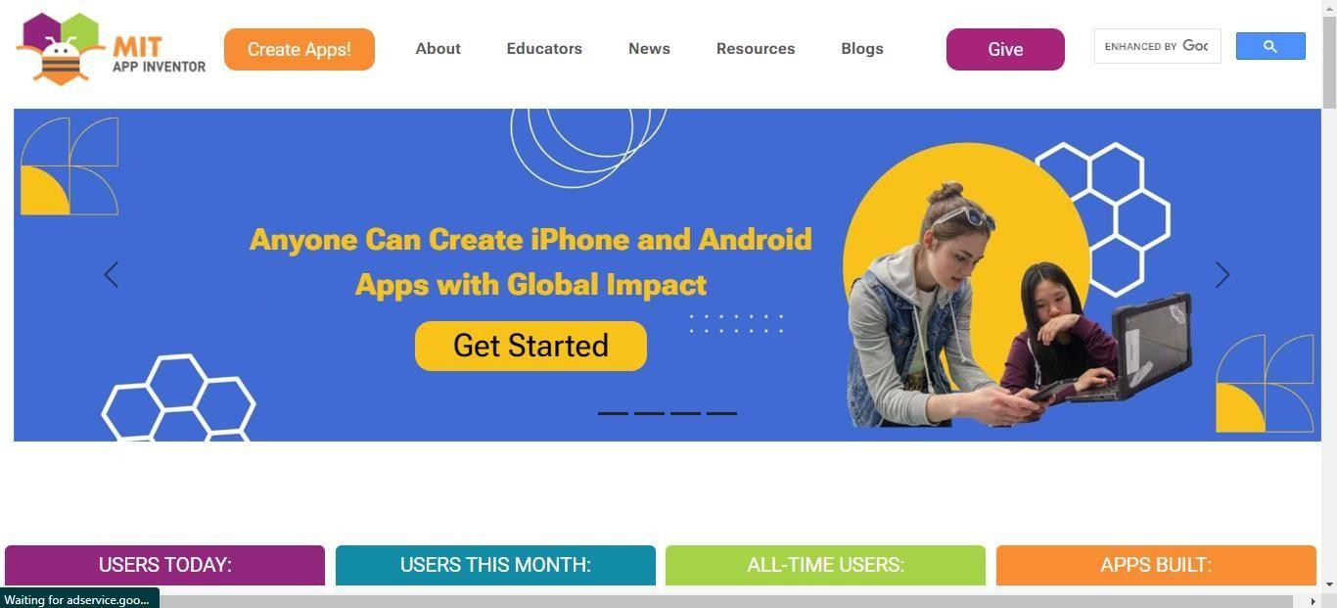MIT App Inventor

Click on Create Apps

Sign in with your google account

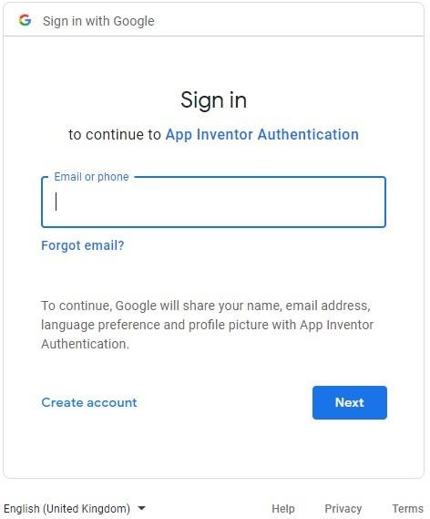

After sign in, Click on Start new project to create a project

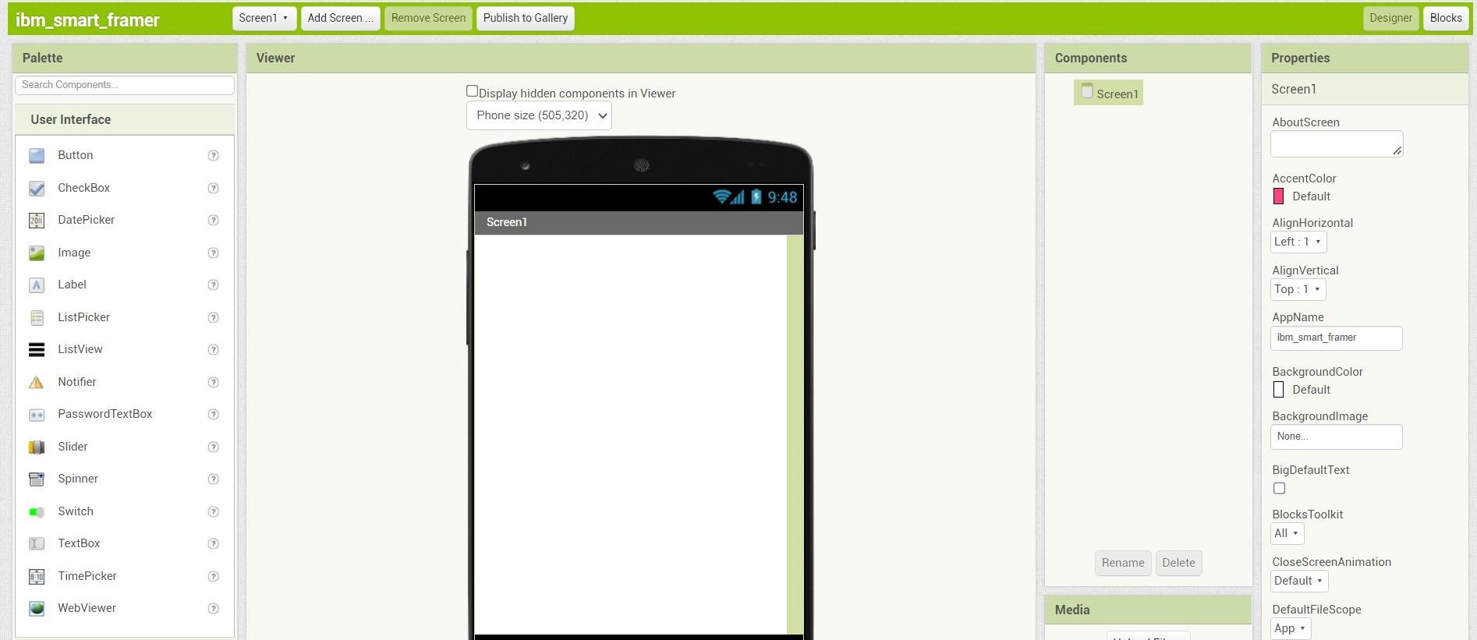

After start new project , now you can create your app by drag and drop the items

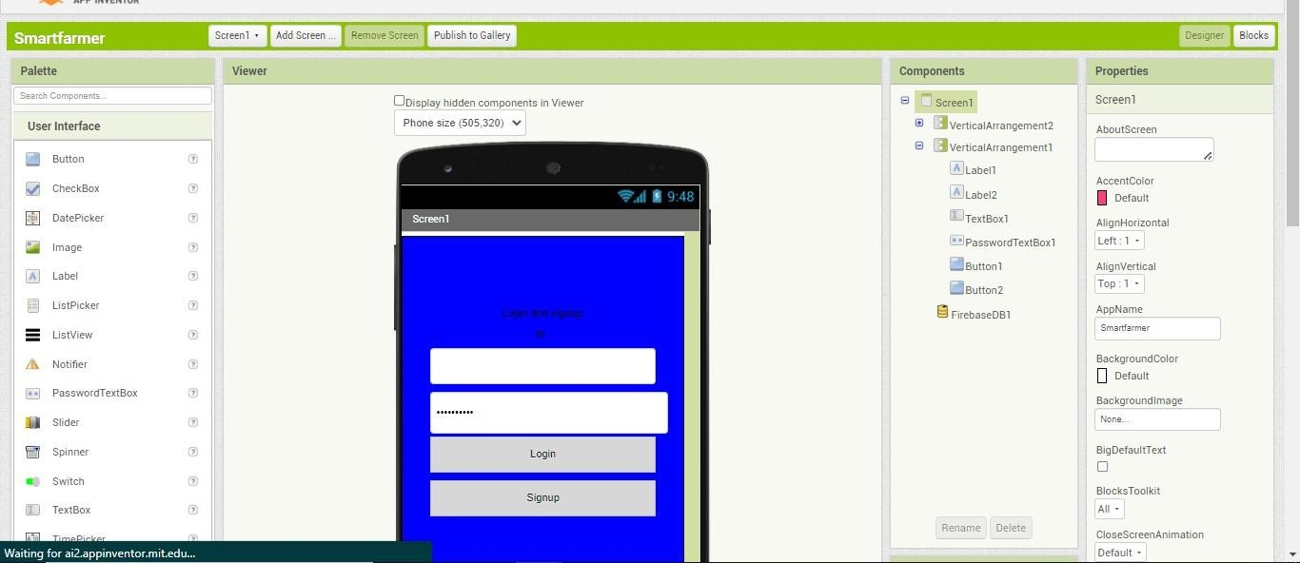

You can view your app in your mobile by using MIT AI2 Companion (which need to installed in your mobile and need to scan QR code) Click Connect > AI Companion to connect with your mobile.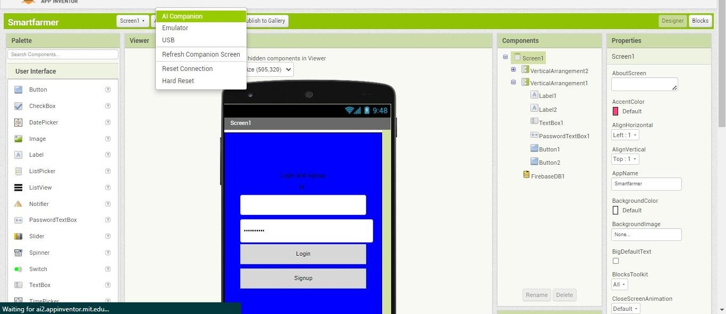

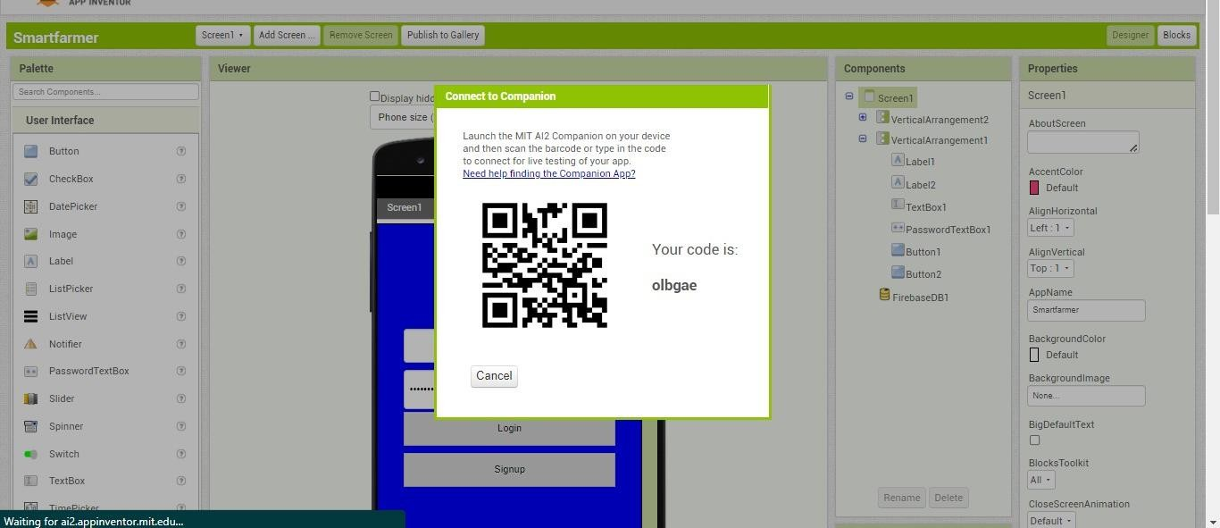

For apk, Click on Build to build the apk for your mobile.